Mean Shift Clustering

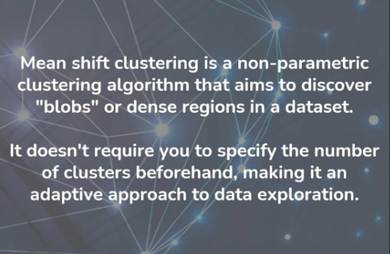

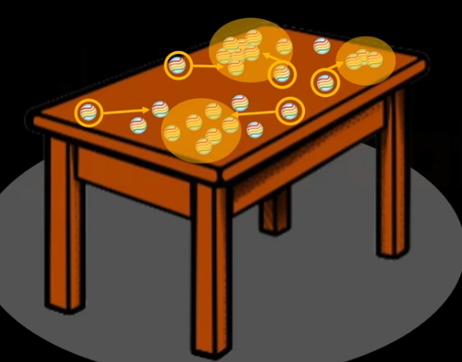
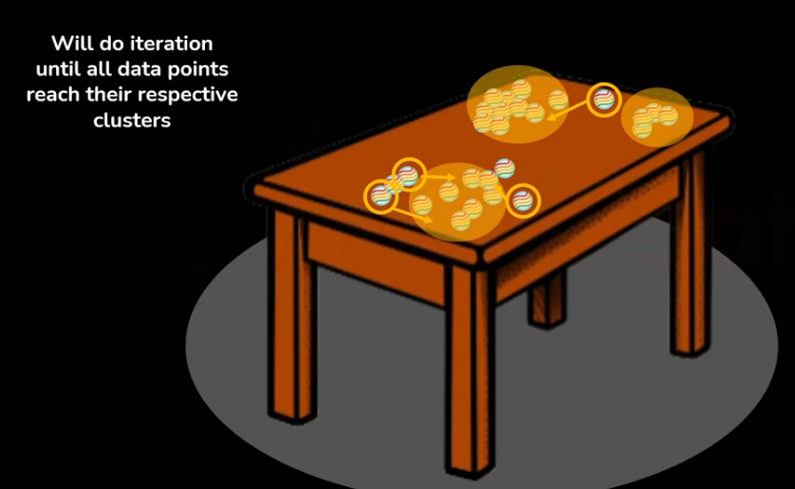
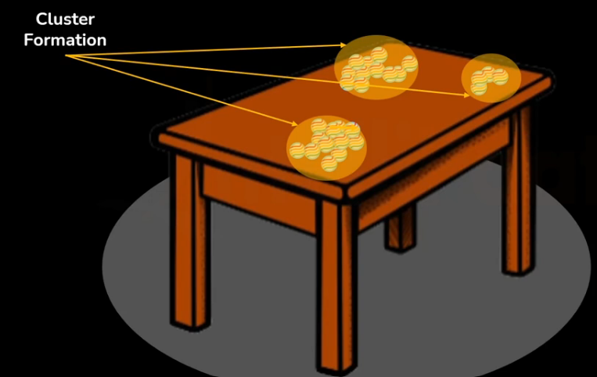

How It Works Step-by-Step:
- Initialization: Start with each data point as a potential cluster center or seed.
- Define Neighborhood: A "kernel" (like a window or circle) is placed around each point, with its size determined by the bandwidth parameter.
- Calculate Mean Shift Vector: For each point, calculate the mean (average location) of all points within its kernel.
- Shift the Point: Move the original point towards this calculated mean (the "mean shift"). This vector points towards the densest region.
- Iterate: Repeat steps 2-4, recalculating the mean and shifting the points iteratively.
- Convergence: The process stops when the mean shift is very small, meaning the point has reached the peak (mode) of a high-density area, or cluster center.
- Clustering: All data points that converge to the same peak belong to the same cluster.

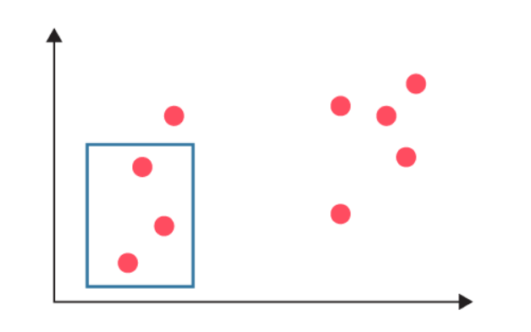

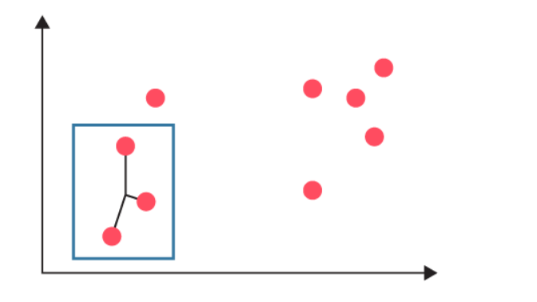

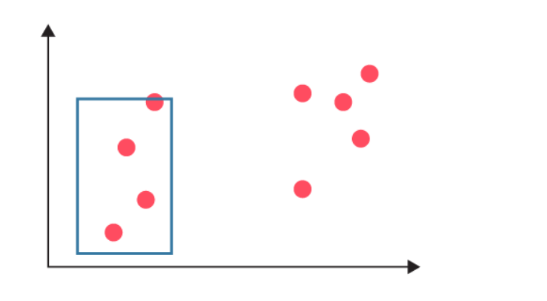

4.1 Kernel Density Estimation (KDE)
Mean Shift is based on estimating the density function:
$$f(x)=\frac{1}{nh^{d}}\sum_{i=1}^{n}{K}\left(\frac{x-x_{i}}{h}\right)$$
Where h is the bandwidth

Advantages:
- Doesn't require specifying the number of clusters (K) beforehand, unlike k-means.
- Can find clusters of arbitrary shapes.
Disadvantages:
- Can be computationally expensive, especially for large datasets.
- Sensitive to the bandwidth parameter choice.

K Means and DB Scan
• Every point belongs to a cluster
• No noise points are marked
• Cluster centers correspond to density peaks

• A few points are labeled as noise (label = -1)
• Clusters are based on density connectivity
Cluster boundaries are defined by eps and min_samples

Why Bandwidth Is So Important

Small h → many small clusters (overfitting)
Large h → few large clusters (underfitting)

